AVL Tree
The first type of self-balancing binary search tree to be invented is the AVL tree. The name AVL tree is coined after its inventor's names − Adelson-Velsky and Landis.
In AVL trees, the difference between the heights of left and right subtrees, known as the Balance Factor, must be at most one. Once the difference exceeds one, the tree automatically executes the balancing algorithm until the difference becomes one again.
BALANCE FACTOR = HEIGHT(LEFT SUBTREE) − HEIGHT(RIGHT SUBTREE)
There are usually four cases of rotation in the balancing algorithm of AVL trees: LL, RR, LR, RL.
LL Rotations
LL rotation is performed when the node is inserted into the right subtree leading to an unbalanced tree. This is a single left rotation to make the tree balanced again −
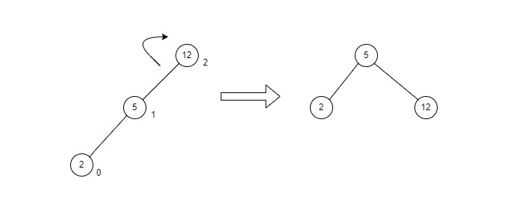
Fig : LL Rotation
The node where the unbalance occurs becomes the left child and the newly added node becomes the right child with the middle node as the parent node.
RR Rotations
RR rotation is performed when the node is inserted into the left subtree leading to an unbalanced tree. This is a single right rotation to make the tree balanced again −
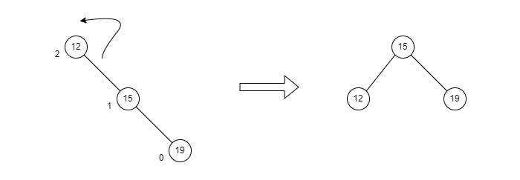
Fig : RR Rotation
The node where the unbalance occurs becomes the right child and the newly added node becomes the left child with the middle node as the parent node.
LR Rotations
LR rotation is the extended version of the previous single rotations, also called a double rotation. It is performed when a node is inserted into the right subtree of the left subtree. The LR rotation is a combination of the left rotation followed by the right rotation. There are multiple steps to be followed to carry this out.
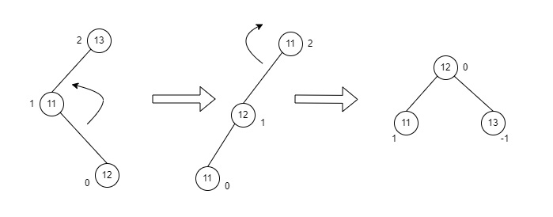
Fig : LR Rotation

RL Rotations
RL rotation is also the extended version of the previous single rotations, hence it is called a double rotation and it is performed if a node is inserted into the left subtree of the right subtree. The RL rotation is a combination of the right rotation followed by the left rotation. There are multiple steps to be followed to carry this out.
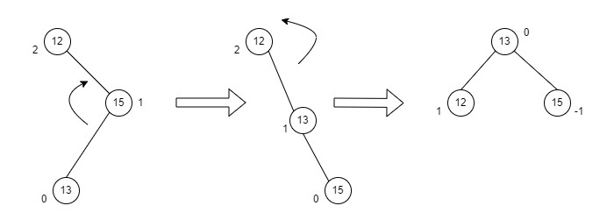
Fig : RL Rotation

